Getting Started with Arduino

1. If you use PCs in SB076, you don’t need to install programs and drivers.
2. Visit the link below. (Getting Started with Arduino)

<http://arduino.cc/en/Guide/HomePage>

1. Select the OS you want to use.
2. To program the quadcopter flight controller, **Multiwii 328P**, we need to install the “Arduino environment,” which is an IDE for Atmel’s AVR series microcontrollers. The environment is written in Java and based on Processing, avr-gcc, and other open source software. Scroll down to “2| Download the Arduino environment”. Click “download page”.
3. Click “Windows” to download Arduino 1.0.3 on Windows 7 PCs.

Download “arduino-1.0.3-windows.zip” then unzip it to the folder “arduino-1.0.3”. This is the working folder. There is no ‘installer’ for the IDE. After unzipping it, you are ready to run the application called “arduino.exe”.

1. Right-click on “arduino.exe” and select “Run as administrator”.

You should see this window.

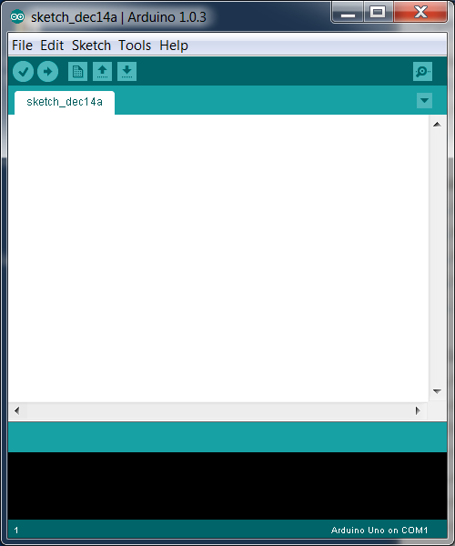

1. To install the driver for the Arduino microcontroller board, follow this link.

<http://arduino.cc/en/Guide/Windows>

### 4 | Install the drivers

**Installing drivers for the “Arduino Duemilanove 328” with Windows7, Vista, or XP:**

* Plug in your board and wait for Windows to begin its driver installation process. After a few moments, the process will fail, despite its best efforts
* Click on the Start Menu, and open up the Control Panel.
* While in the Control Panel, navigate to System and Security. Next, click on System. Once the System window is up, open the Device Manager.
* Look under Ports (COM & LPT). You should see an open port named "Arduino UNO (COMxx)"
* Right click on the "Arduino UNO (COmxx)" port and choose the "Update Driver Software" option.
* Next, choose the "Browse my computer for Driver software" option.
* Finally, navigate to and select the Uno's driver file, named **"ArduinoUNO.inf"**, located in the "Drivers" folder of the Arduino Software download (not the "FTDI USB Drivers" sub-directory).
* Windows will finish up the driver installation from there.

1. Go to Windows’ Control Panel -> Device Manager -> Ports to check the driver. You should see this screen.

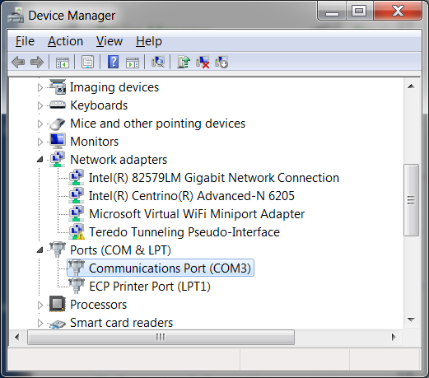

1. [Option] To test the driver and the Arduino board, continue on next steps.

5 | Launch the Arduino application

6 | Open the blink example

7 | Select your board

8 | Select your serial port

9 | Upload the program

1. The flight controller board, **Multiwii 328**, does have a USB connector to connect to PC for programming.
2. Go to Windows’ Control Panel -> Device Manager -> Ports to check the driver (FTDI USB Driver). You should see this screen.

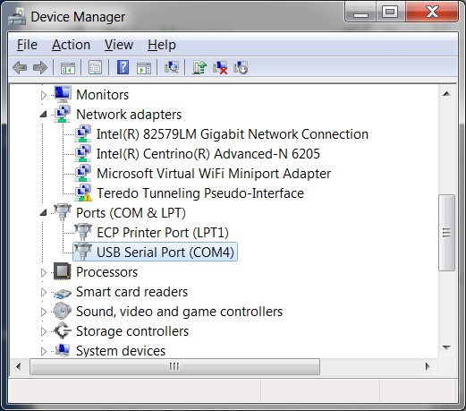

Getting Started with Multi Wii Flight Control Board

* + 1. Read

<http://www.geeetech.com/wiki/index.php/MultiWii_Multi-Copter_Flight_Control_Board>

* + 1. Read

<http://www.multiwii.com/software>

* + 1. To download a source file (firmware) for the control board, called “MultiWii_2_x” and an application program for a PC called “MultiWiiConf_2_x”, go to

<http://code.google.com/p/multiwii/>

and click on “MultiWii_2_x” to download.

Download “MultiWii_2_x.zip” and unzip it. It contains “MultiWii_2_x” and “MultiWiiConf_2_x”.

* + 1. Right-click on “arduino.exe” and select “Run as administrator”. [Note: “arduino.exe” (arduino-1.0.3) cannot run under H: network drive. We cannot open an arduino file (.ino) in the IDE if the file is on the network drive. The source files should be on a local drive (e.g. Desktop)].

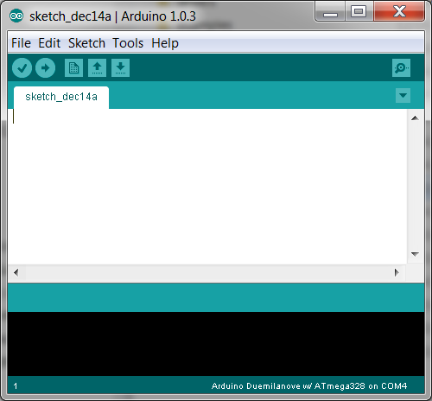

* + 1. To import a file (.ino) click File -> Open.
    2. Make sure that you follow one of the “Safety Rules”: Disconnect battery/powered off when making alterations, especially when uploading codes for a flight controller (microcontroller).

If you have the battery connected to the quadcopter while you download the code, the copter will fly to you without any warning! Your neighbor or you will get hurt or it will crash right away…

* + 1. Click Tools -> Board -> Select Arduino **Duemilanove 328**
    2. Click Tools -> Serial Port -> Select a COM x.
    3. Click to “upload” (e.g. compile and download to the target arduino board)
 $$⇒$$

   4. To lunch the PC application MultiConf_2_x, click on “MultiWiiConf_2_x.exe”, under MultiWiiConf_2_x -> application.windows32 -> MultiWiiConf_2_x.exe.

Wait for a minute. Be patient….

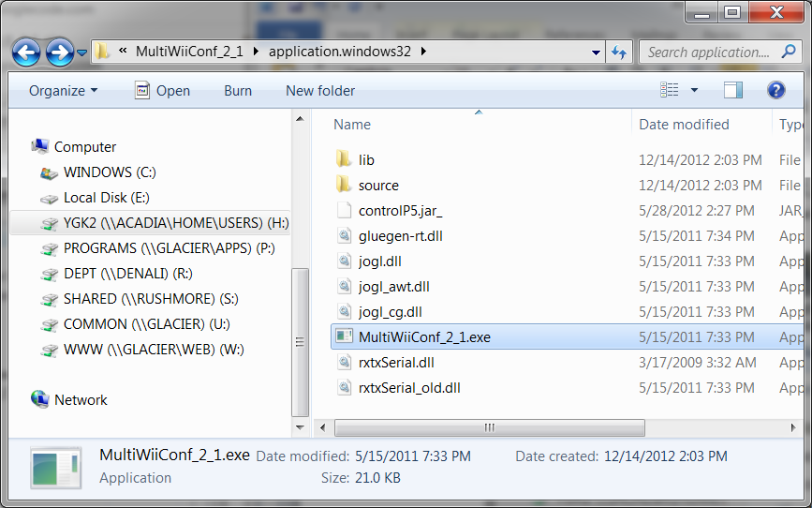

* + 1. After a minute, you should see

